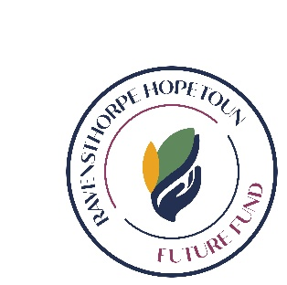
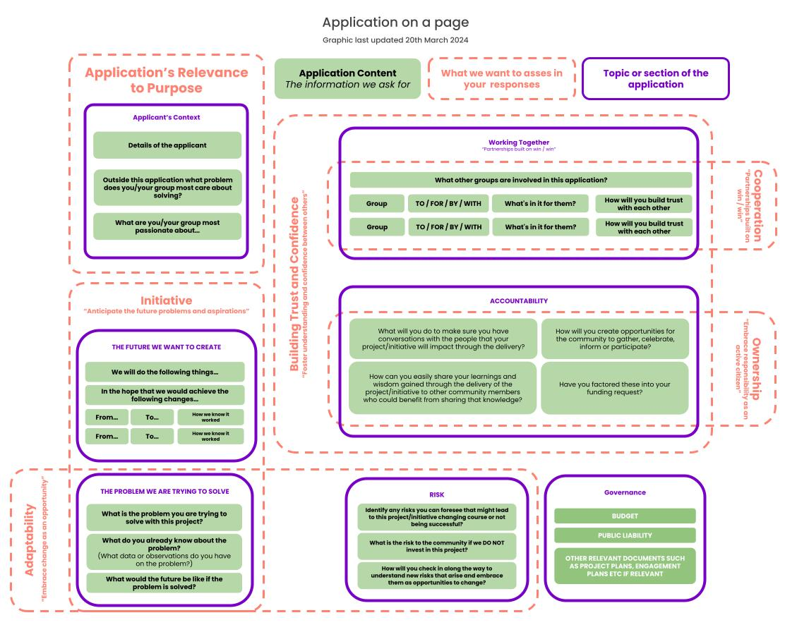
How the application process demonstrates the desired behaviours

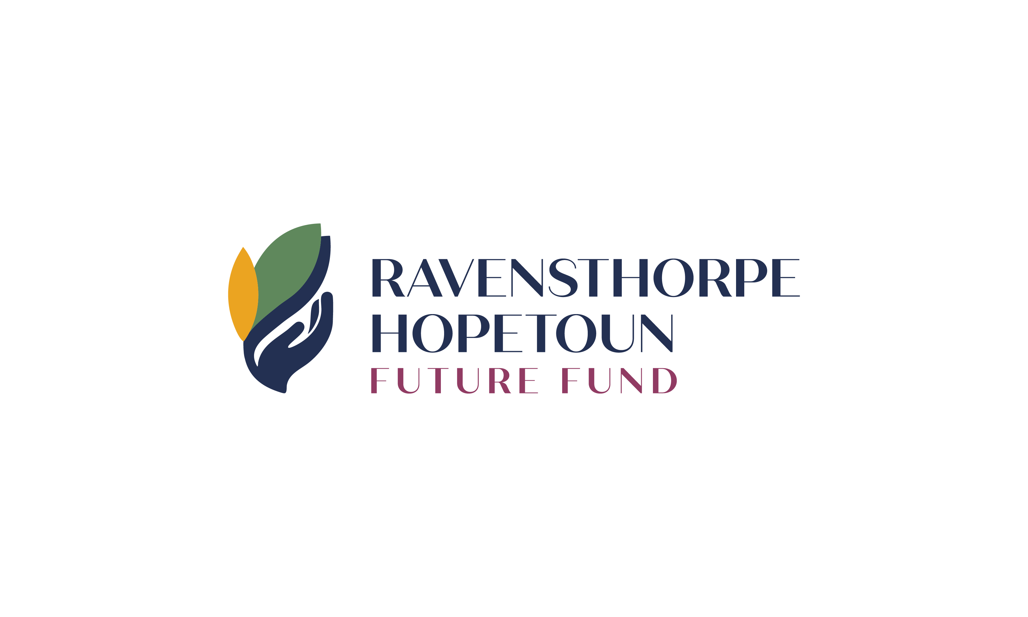

RHFF Application Form 2026

Not for Profit
The Ravensthorpe Hopetoun Future Fund was founded to provide funding for-
(1) Charitable endeavours that will provide community or welfare benefit to all or a substantial proportion of persons who are ordinarily resident in the Area; and
(2) facilities and services that improve the welfare, culture or amenity of all or a substantial proportion of persons ordinarily resident in the Area.

Applications open on 1 April 2026 and close 30 April 2026.

Please read the Grant Application Guidelines carefully before completing this application. This form includes examples which are provided as a guide only.

- Applicant Details:

- What is the name of your Project/Initiative?

- Is your project – please select one
Infrastructure
Event
Service
Training
Other (please list) __________________________________________

- Are you a single organisation or a partnership/collaboration?

- Amount requested – ex GST (we do not pay GST)

- Who is the Application Rep that will be able to advocate for this project and act as the main point of contact?

Application Rep Details:

Business Name/ Trading as:
ABN number:
Website:
Bank details:
Registered for GST: Yes/No
Postal Address:
Contact Number:
Role:
Email:
Secondary contact:

- Group Details (if a partnership/collaboration please insert extra tables and include details of all partners):

Name:
Postal address:
Email:
Role:
Contact number:

- Why your group comes together (Applicant Context)
- Outside this application/project, what problem does your group most care about solving in the community?

- Why does your organisation exist? What is your purpose?

The future we want to see…
- The problem we want to solve…

- What is your Project/Initiative ?

- What is the problem you are trying to solve with this project and why?

- What do you already know about the problem? (When does the problem arise? Who does it affect? What data or observations do you have on the problem? What attempts have been made to solve the problem?)

- What would the future be like if the problem is solved?

- When do you see your Project/Initiative starting in the current financial year? What is your estimated time line for the project?

- The future we want to create…
As a proactive group, within this community, we want to tackle this problem through our Project/Initiative :

- We will do the following things…

- In the hope that we would achieve the following changes…

From…  (current reality) | To…  (Future reality) | How will we know our approach is working?
Example only: Kids drifting around town | Example only: Dedicated safe space kids can be unsupervised | - Example only: See a decrease in antisocial behaviour  - Example only: The park would see a large amount of community activity
Example only: Local businesses lacking qualified staff | Example only: Local people upskilled to fill vacancies | - Example only: Fewer job vacancies  - Example only: Locals growing in confidence
Example only: Deficit in leadership skills across the community | Example only: Confident and proficient local leaders | - Example only: Community groups fill positions easily  - Example only: Orgs can proactively respond to challenges
- How does your project align with the Future Funds purpose? (This information is located at the top of the form)

How will we create that future?
- Co-operation

- What other groups are involved in this application?

TO / FOR / WITH / BY Definitions
To: Actions done to a partner based on what a group thinks it needs - “we know the answers and are responsible for delivering them”

For: Actions done for a partner informed by consultation - “we would like to know your opinions and ideas and then we will do the rest”

With: Collaborative action done with a partner - “we can achieve more when we work with others”

By: Actions done by a partner that are enabled, allowed, or encouraged - “let’s work out what we want to see more of and enable that to happen”

Group | What's in it for them? | Is this partnership “To, For, By or With” | How will we build trust and confidence with each other?
Example only: Ravensthorpe District High School | Example only: Reduction time spent dealing with the fallout of antisocial behaviour after school hours. | Example only: To | Example only: Regular meeting once a month to talk about the project
Example only: Ravensthorpe Youth Club | Example only: Youth can self-organise and are not reliant on volunteer-led, organised activity | Example only: With | Example only: Involve members in the design process/ site selection.

- Have all of your projects/initiatives that have previously received funding/grants/sponsorship by RHFF or any other source been successfully acquitted? If not, why not?

- Is your organisation/business sufficiently equipped to deliver the initiative? E.g. Human resources or finances

- If RHFF has previously granted your organisation/business funds then describe the purpose and outcome.

- Accountability
A self determined community is accountable to each other. Please demonstrate your accountability through the following questions:
(Keep it simple, it could be a cup of tea at the CRC, an online Facebook group, participating in community collabs or even a social celebration)

- How will you create opportunities for the community to gather (to celebrate, inform or participate)?

- What will you do to make sure you have conversations with the people that your Project/Initiative will impact through the delivery?

- How will you easily share your learnings and wisdom gained through the delivery of the Project/Initiative with other community members who could benefit from the knowledge?

- On completion, how will you prove that funds have been spent in line with the application and the intended purpose of the Ravensthorpe Hopetoun Future Fund?

- Have you factored these activities into your funding request?

- Risk
Risk is inherent in every project. As an investor in a proactive community, the RHFF understands that the future is full of uncertainties. What is important is that we anticipate the future problems of the community.
- Identify any risks you can foresee that might lead to this Project/Initiative changing course or not being successful?

- What is the risk to the community if we DO NOT invest in this project?

- How will you check in along the way to understand new risks that arise and embrace them as opportunities to change?

- What risks is your organisation taking in the project?

NOTE: Successful applicants may be required to provide additional risk documentation. If you already have risk documentation, please feel free to proactively include it in your application.

- Budget

Please provide any quotes, prices/costings you have received that relates to this project.

Project Income | Amount ex GST
RHFF contribution
Total project cash income

(Please enter all figures exclusive of GST as RHFF is not registered for GST or required to be and the provision of the grant is exclusive of GST.)

Project Costs | Amount
Total project costs

In kind contributions  *volunteer hours calculated at $40 p/h | Est. Dollar value
- Signed Declaration

If there are multiple partners to this funding application, each partner needs to provide a signed declaration when submitting the application.

DECLARATION

I have read the Ravensthorpe Hopetoun Future Fund’s Grant Application Guidelines 2026.

I certify that all information provided is current and correct. Furthermore, I give permission to the Future Fund to contact any relevant persons or organisations in the processing of this application and agree to return any funds not spent in line with the grant application.

I, ________________________________(insert name of person signing) have delegated authority to sign this

application on behalf of _______________________________________________________ (applicant).

Signed:
Name:
Position:
Date:

